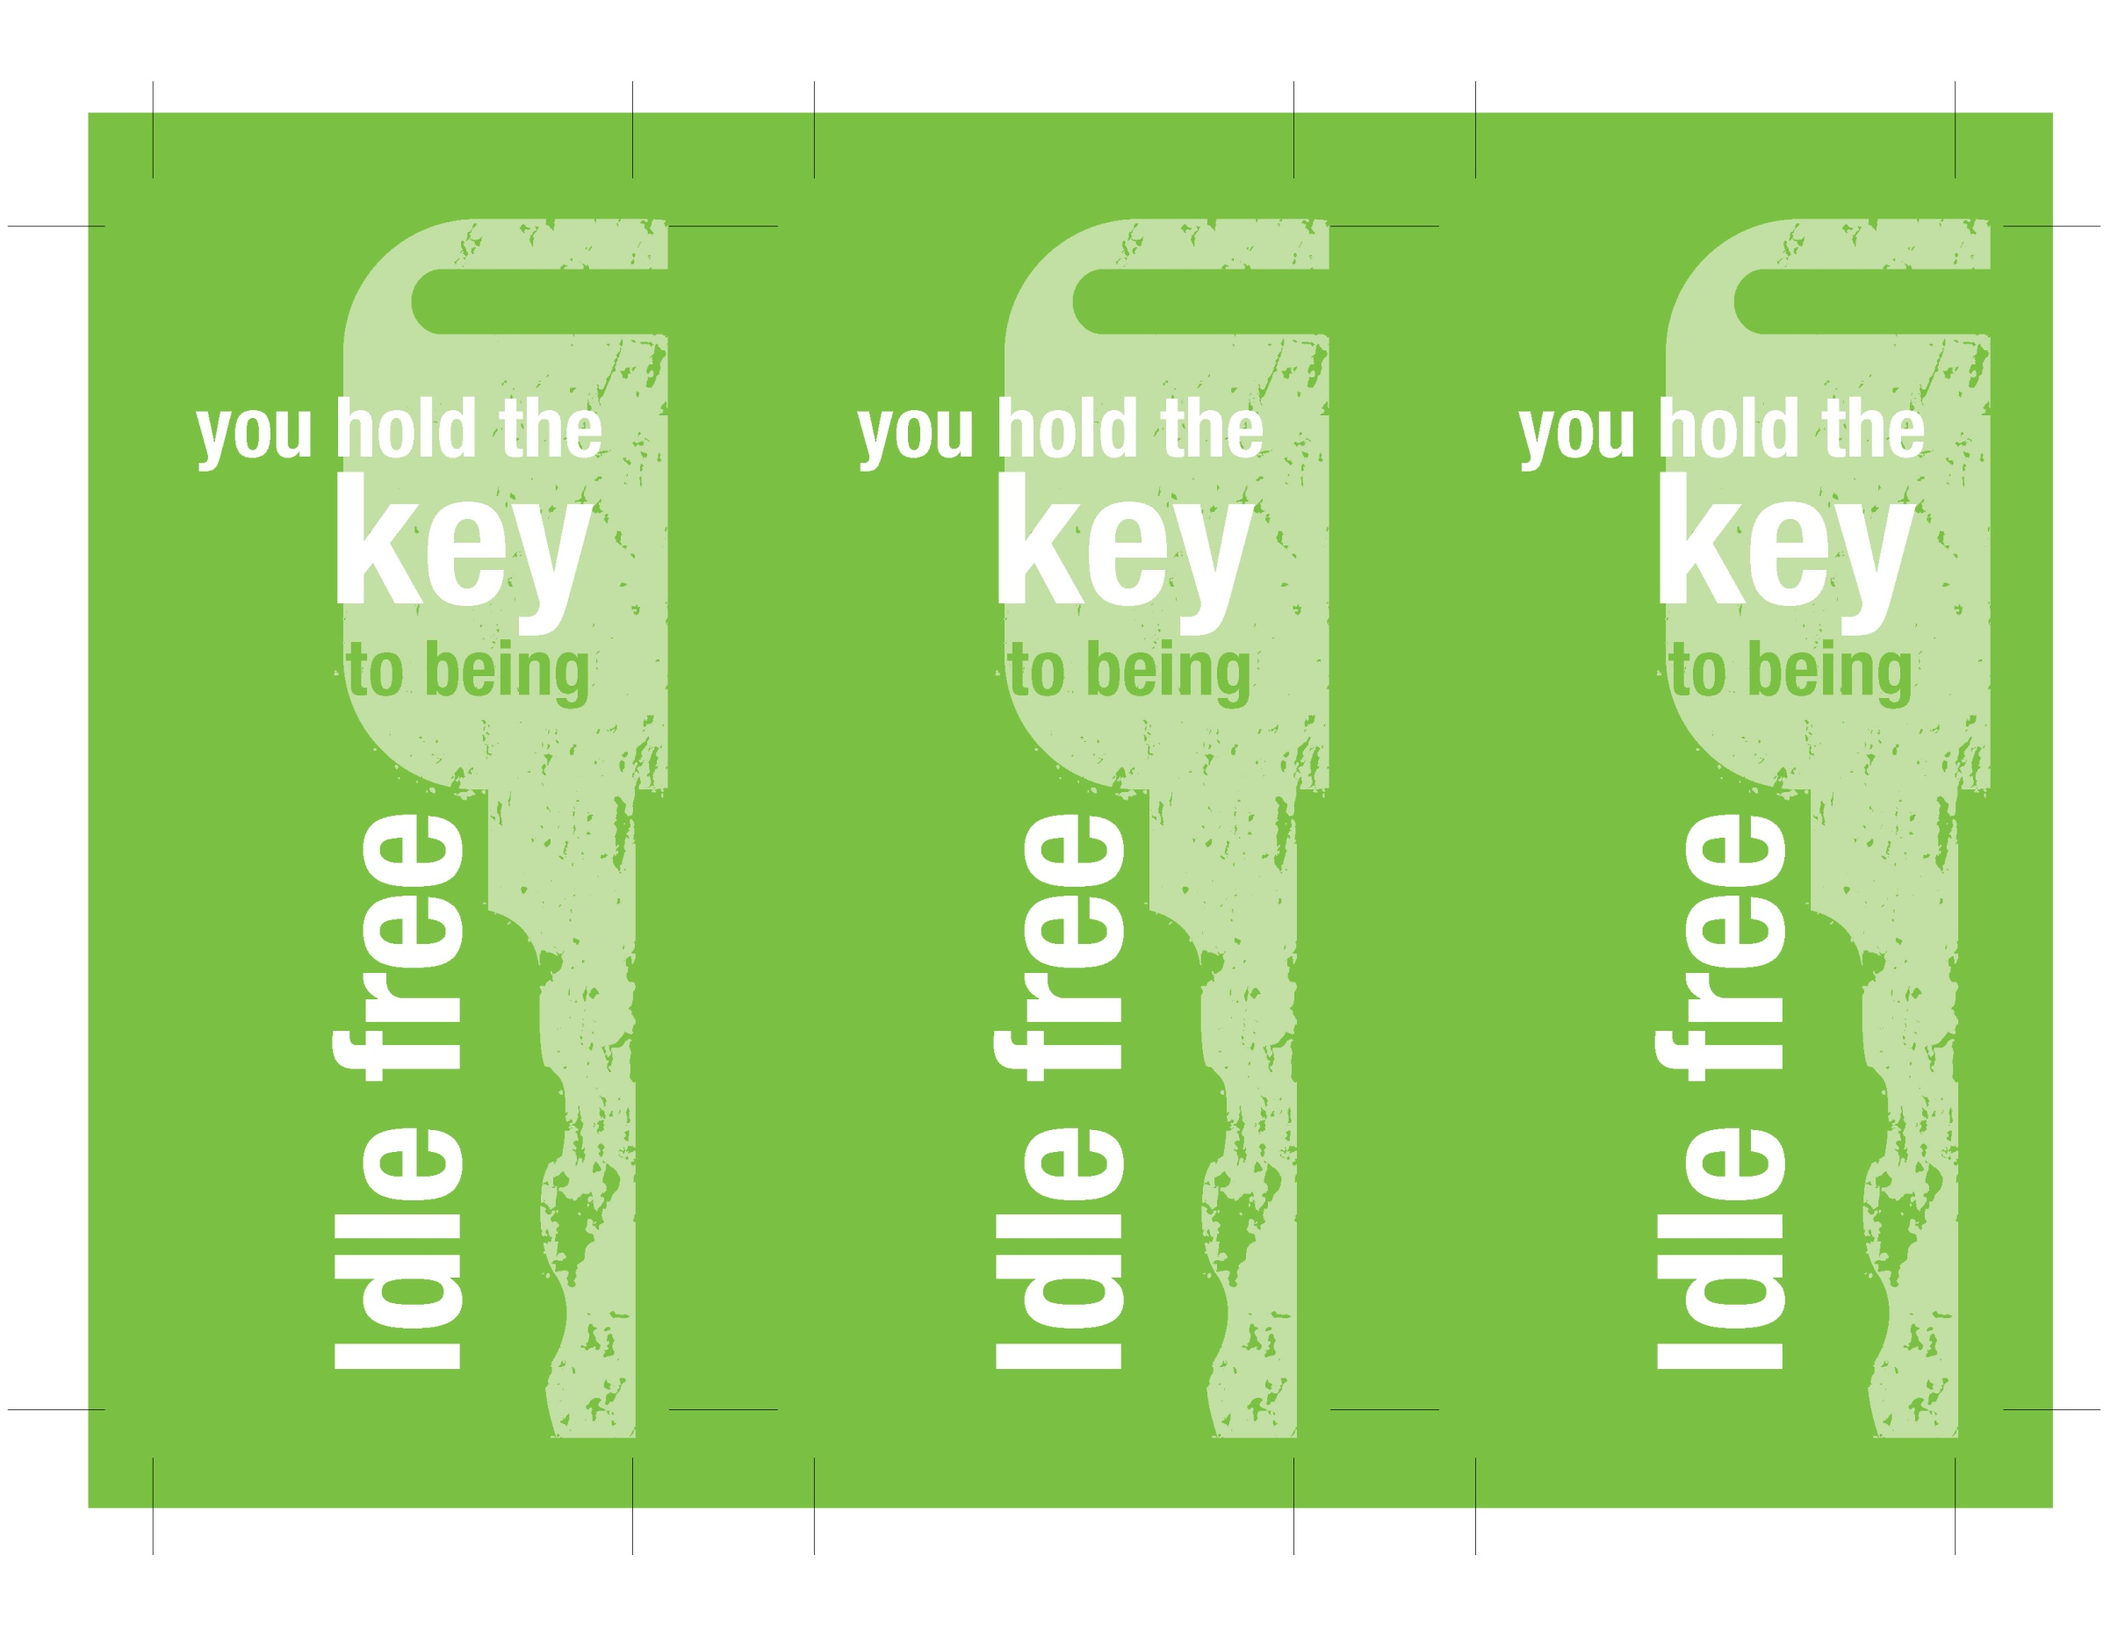
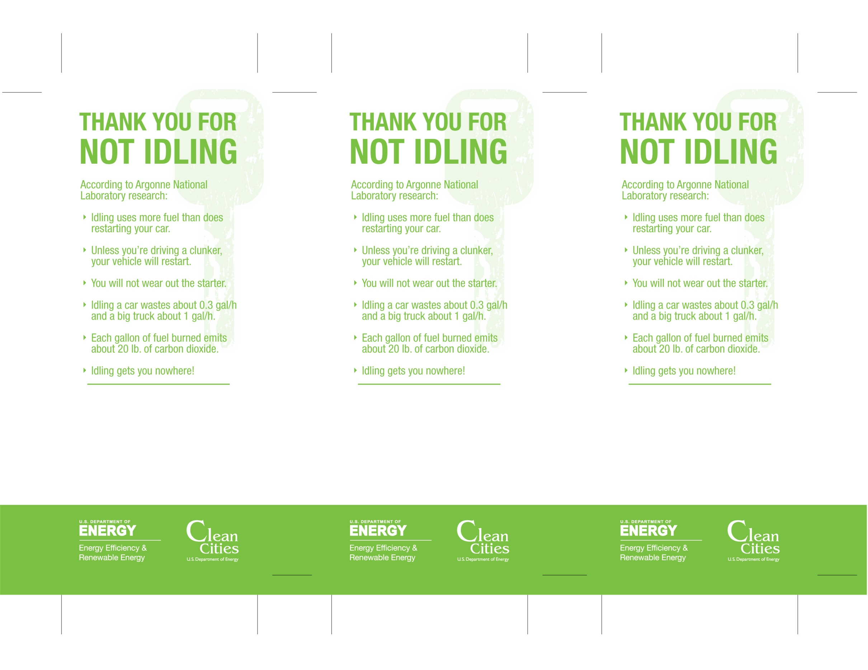
ILLINOIS REGULATION
For diesels ≥ 8,000 lb. (GVW), idling is limited to 10 min/h in and around the largest cities. Sleepers and vehicles in queue are exempted.

CITY OF CHICAGO REGULATION
Idling is limited to 3 min/h for all diesels. Sleepers included if temperature is 32˚–80˚F.
STATE REGULATION
Summarize your state idling regulation here (see example in left panel).

LOCAL REGULATION
Summarize your county or municipal idling regulation here (see example in left panel).

STATE REGULATION
Summarize your state idling regulation here (see example in left panel).

LOCAL REGULATION
Summarize your county or municipal idling regulation here (see example in left panel).

